MILESTONE-1
By-Pydah Hasitha Sai Keerthana
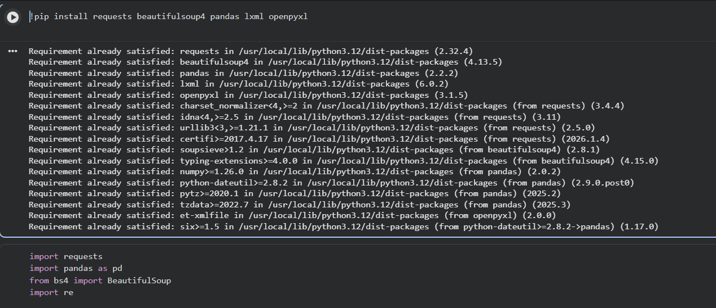
- This command installs the external Python libraries required for web scraping, data parsing, and data analysis in the project environment.
- This code initializes the environment setup for the web-scraping and data-processing pipeline.
- It imports the necessary Python libraries and defines HTTP request headers required for reliable web access.

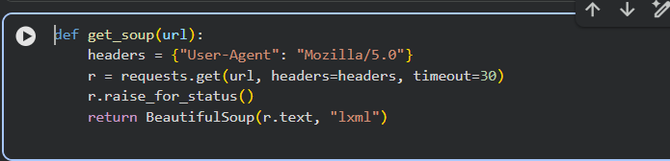
This function:
- Takes a URL as input.
- Sends a request using browser-like headers.
- Prevents blocking.
- Parses HTML using BeautifulSoup.
- Returns parsed webpage.

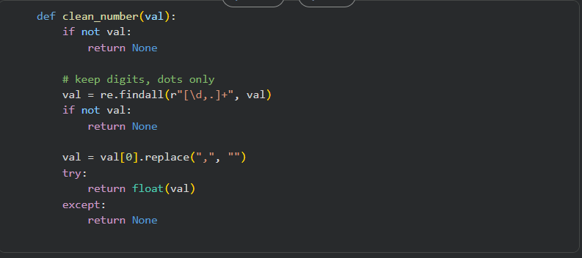
This function:
- Extracts only numbers from messy text.
- Removes commas.
- Converts to float.
- Returns None if conversion fails.
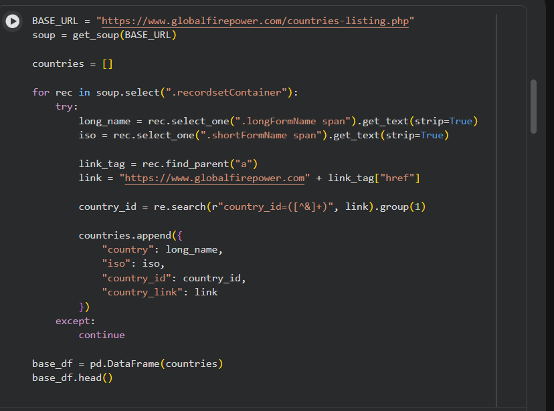
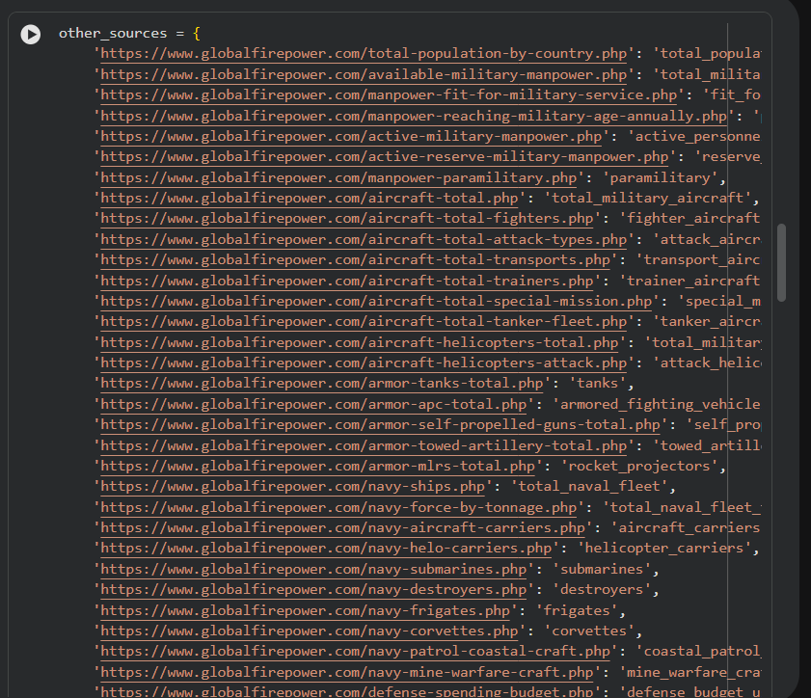
Explanation:
- Stores all metric URLs in one list.
- Each entry has:
  - Metric name
  - Actual webpage link
This allows one unified scraping pipeline.
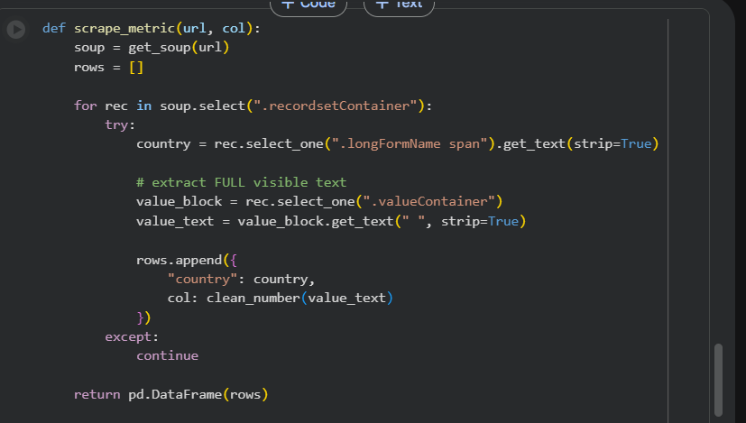
Explanation:
This is the main scraping logic.
It:
- Loads webpage using get_soup()
- Finds all country cards (recordsetContainer)
- Extracts:
  - Country name
  - ISO code
  - Metric value
- Cleans value
- Returns structured list

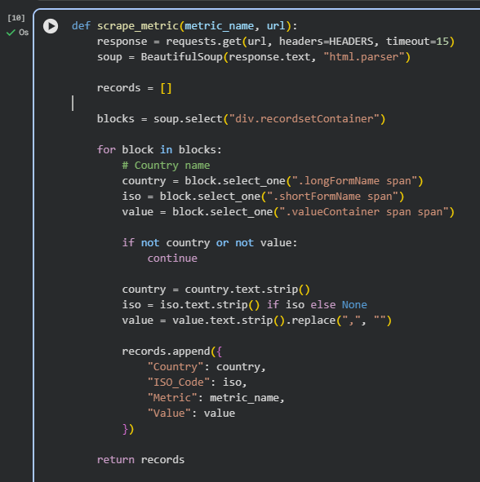
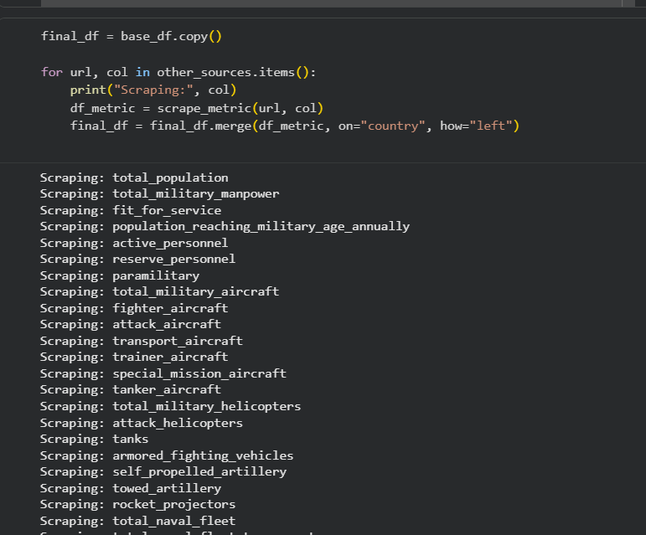
- This function scrapes one GlobalFirepower ranking page and extracts:
- Country name
- ISO-3 country code
- A specific military/economic metric value
- It returns the data in a structured, reusable format, enabling a single unified scraping pipeline for multiple indicators.

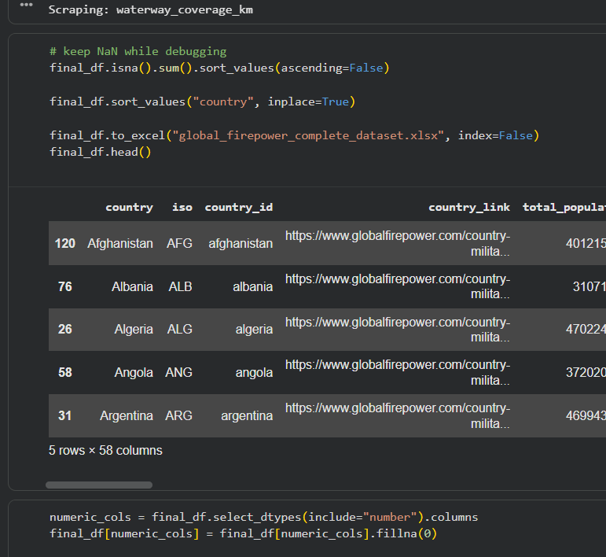
Explanation:
- Converts collected list into structured DataFrame.
- Displays first 5 rows.
- Checks structure.

EXCEL SHEET OF THE DATASET AFTER WEB SCRAPING AND DATA CLEANING
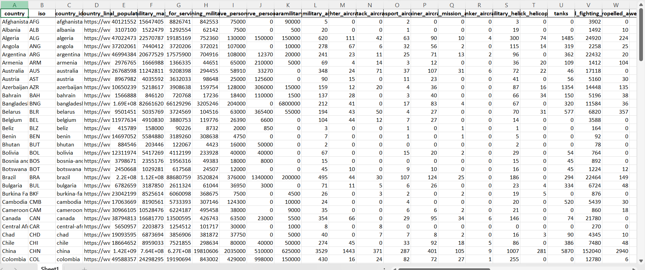

- Conclusion (Milestone 1)
- Milestone 1 successfully achieved its objective of collecting, cleaning, and structuring large-scale military and strategic data from GlobalFirepower ranking pages using a unified and automated data pipeline.
- Through systematic web scraping, the project extracted multi-dimensional indicators covering manpower, air power, land forces, naval strength, economic capacity, infrastructure, natural resources, and geographic factors for 145 countries. The scraped data was transformed from raw HTML into a clean, standardized, and analysis-ready dataset.
- A key technical achievement of this milestone was the identification and correct handling of card-based HTML structures, rather than traditional tables, enabling accurate extraction of country names, ISO codes, and metric values. The final dataset was reshaped into a wide format, ensuring one row per country and one column per indicator, and exported successfully as an Excel file suitable for analytical tools such as Tableau and Power BI.
- Thus, Milestone 1 establishes a robust and scalable data foundation for advanced analytics and visualization in subsequent milestones.

- Key Insights from Milestone 1
- Unified Data Pipeline Effectiveness
The use of a single reusable scraping function and centralized URL configuration proved effective in handling 50+ diverse indicators without code duplication. This design significantly improved scalability and maintainability.
- Data Quality and Completeness
After cleaning and restructuring:
- Missing values were minimal and handled safely
- All numeric fields were standardized
- The dataset achieved high completeness across countries and metrics
This confirms the reliability of GlobalFirepower ranking pages as a data source.

- Analytical Readiness
The final output:
- Contains 145 rows × 37 columns
- Is free from formatting inconsistencies
- Is directly usable for:
  - Comparative analysis
  - KPI computation
  - Dashboard development
- Ethical and Robust Scraping Practices
The inclusion of request headers and controlled delays ensured:
- Ethical data collection
- Reduced risk of blocking
- Stable execution across all URLs

